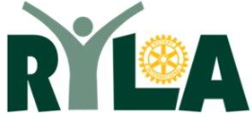
Rotary Youth Leadership Awards
24th Aug to 31st Aug 2024

Gain and develop skills in team work, team building and leadership.

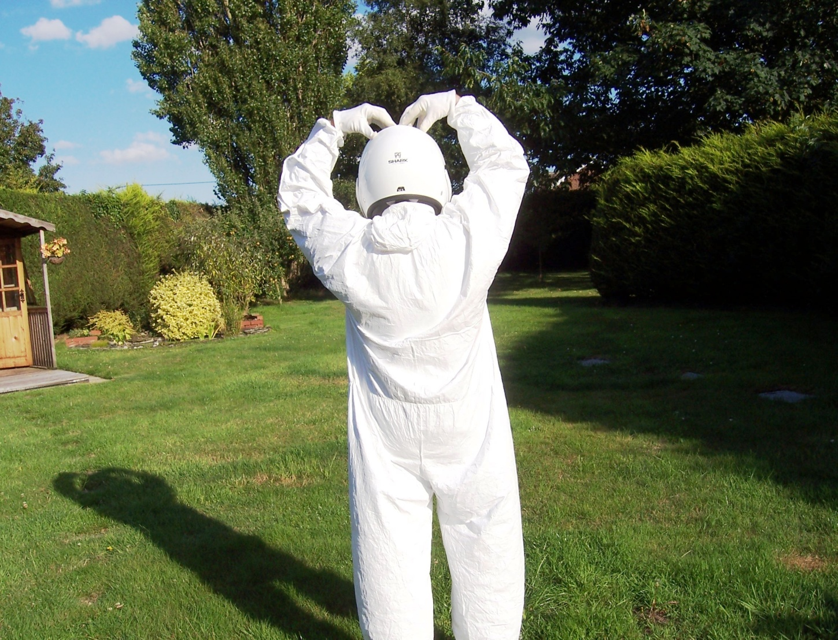
Grafham Water Centre
£825.00 per Delegate
Restricted to 50 delegates
Reserve a place now
www.ryla.co.uk
Visits/information etc. David Simpson
01394 385839(H) 07718 889482(M)
Email: davidrsimpsoncar@btinternet.com
A life enhanceing experience For young people age
18 to 26

